Portable Multimedia Stereo Speakers
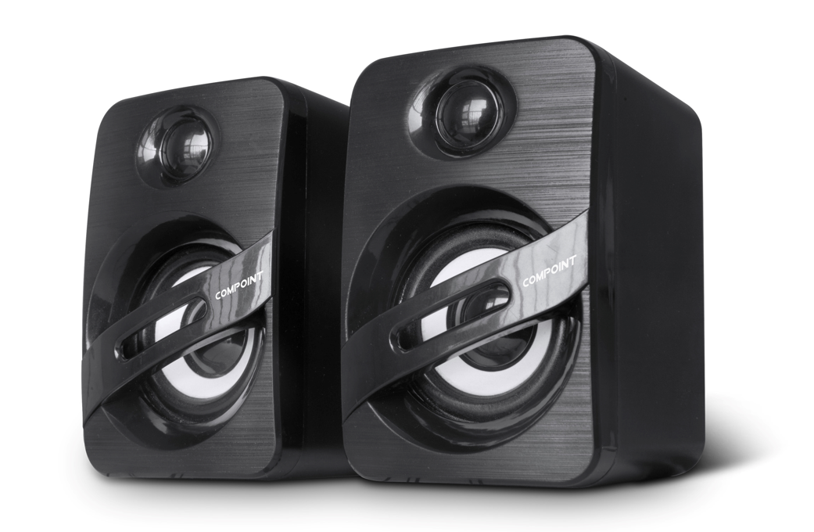
Small, stylish and fully portable Stereo Speakers
Standard 3.5mm Phone Jacks
No Power Supply needed- Powered by separate USB connector
Integral active Amplifier using BassBoost technology
Superior Sound reproduction and quality for such small Speakers
Ideal for Digital Music, Gaming, Skype and Business Communications
Ideal for MicrosoftTM WindowsTM and MACTM
Speaker size 2"
Rated Power 3W*2
Frequency 90Hz-20KHz
Power 5V USB
S/N > 86dB

